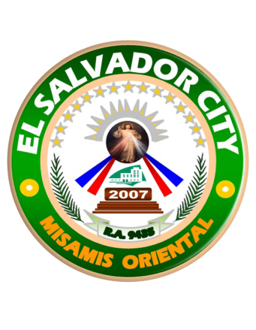

CITY GOVERNMENT OF EL SALVADOR

CITIZEN’S CHARTER
2020 (1st Edition)

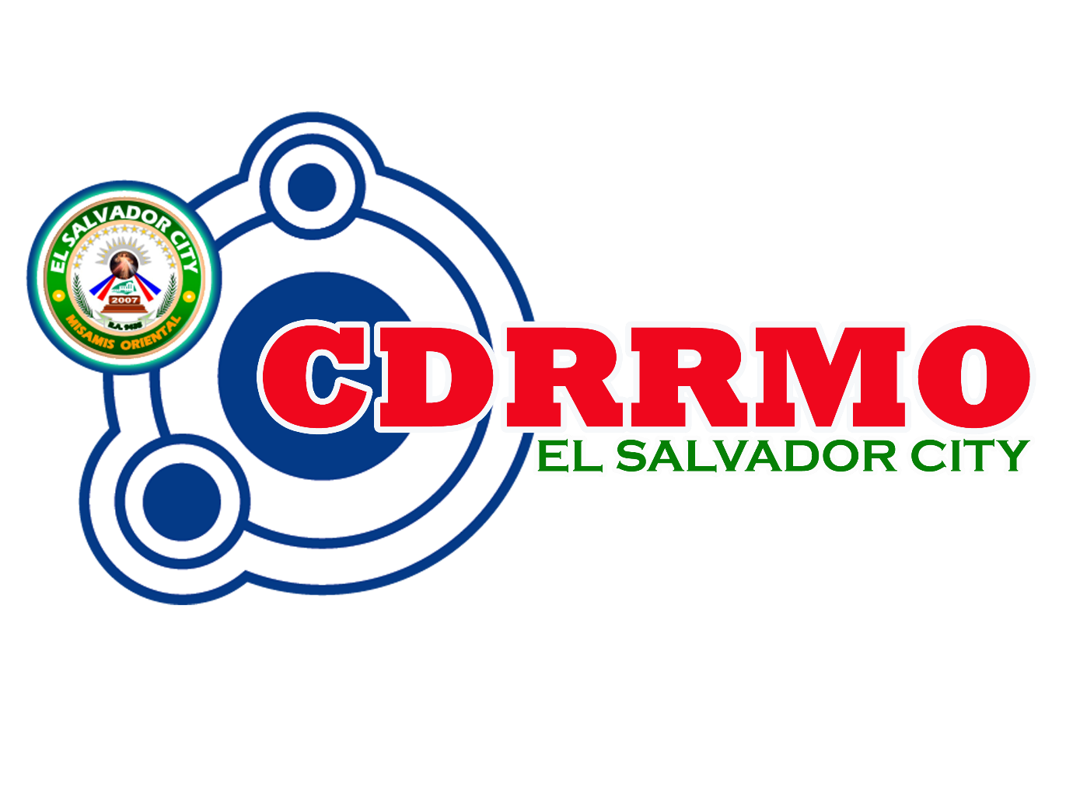

CITY DISASTER RISK REDUCTION AND MANAGEMENT OFFICE
City DRRM Operations Center Bldg., Zone 1, Poblacion
El Salvador City, Misamis Oriental

I. Mandate:

The City Disaster Risk Reduction and Management Office (CDRRMO), as the coordinating office of the City Disaster Risk Reduction and Management Council (CDRRMC), within their territorial jurisdiction, shall be responsible for setting the direction, development, implementation, and coordination of DRRM programs, and shall perform the following functions and those that may be authorized by the CDRRMC:

A. DRRM Research and Planning
- Design, program, and coordinate DRRM activities, consistent with the NDRRMC’s standards and guidelines;
- Facilitate and support risk assessments and contingency planning activities at the local level;
- Consolidate local disaster risk information which includes natural hazards, vulnerabilities, and climate change risks, and maintain a local risk map;
- Conduct research and development initiatives on DRRM;
- Formulate and implement a comprehensive and integrated Local DRRM Plan (LDRRMP) in accordance with the national, regional, and provincial framework, and policies on DRR in close coordination with the Local Development Council (LDC);
- Prepare and submit to the Local Sanggunian through the Local DRRM Council and the LDC the annual LDRRMO Plan and budget, the proposed programming of the LDRRMF, other dedicated DRRM resources, and other regular funding source/s and budgetary support of the LDRRMO or BDRRMC;
- Maintain a database of human resource and their capacities, equipment, directories, and location of critical infrastructures such as hospitals and evacuation centers;
- Serve as the Secretariat and executive arm of the Local DRRM Council (LDRRMC);
- Recommend through the LDRRMC the enactment of local ordinances consistent with RA 10121; Prepare and submit, through the LDRRMC and the LDC, the report on the utilization of the LDRRMF and other dedicated DRRM resources to the local COA, copy furnished the regional director of the Office of Civil Defense (OCD) and the local government operations officer of the DILG; and Involve the most vulnerable sectors (women, children, senior citizens, and PWD) in risk assessment and planning

B. DRRM Administrative and Training
- Organize and conduct training, orientation, and knowledge management activities on DRRM at the local level;
- Identify, assess, and manage the hazards, vulnerabilities and risks that may occur in their locality;
- Identify and implement cost-effective risk reduction measures and or strategies;
- Disseminate information and raise public awareness about those hazards, vulnerabilities, and risks;
- Take all necessary steps on a continuing basis to maintain, provide, or arrange the provision of, or to otherwise make available, suitably-trained and competent personnel for effective civil defense and DRRM in its area;
- Organize, train, equip and supervise the local emergency response teams and the accredited community disaster volunteers (ACDVs), ensuring that humanitarian aid workers are equipped with basic skills to assist mothers to breastfeed;
- Within its area, promote and raise public awareness of, and compliance with RA 10121 and legislative provisions relevant to the purpose of the latter;
- Implement policies, approve plans and programs of the LDRRMC consistent with the policies and guidelines laid down in RA 10121; and
- Train the most vulnerable sectors (women, children, senior citizens, and PWD) in DRRM, especially in disaster preparedness.

C. DRRM Operations and Warning
- Operate a multi-hazard early warning system, linked to DRR to provide accurate and timely advice to national or local emergency response organizations and to the general public, through diverse mass media, particularly radio, landline communications, and technologies for communication within rural communities;
- Conduct continuous disaster monitoring and mobilize instrumentalities and entities of the LGUs, CSOs, private groups and organized volunteers, to utilize their facilities and resources for the protection and preservation of life and properties during emergencies in accordance with existing policies and procedures;
- Develop, strengthen, and operationalize mechanisms for partnership or networking with the private sector, CSOs, and volunteer groups;
- Respond to and manage the adverse effects of emergencies and carry out recovery activities in the affected area, ensuring that there is an efficient mechanism for immediate delivery of food, shelter and medical supplies for women and children, endeavor to create a special place where internally-displaced mothers can find help with breastfeeding, feed and care for their babies and give support to each other;
- Coordinate other DRRM activities;
- Establish linkage and or network with other LGUs for DRR and emergency response purposes;
- Establish a provincial, city or municipal, and barangay DRRM Operations Center;
- Give early warning to the most vulnerable sectors (women, children, senior citizens, and PWD) to respond to their needs; and
- Respond to and manage the adverse effects of emergency and carry out recovery activities to the most vulnerable areas especially to the vulnerable sectors (women, children, senior citizens, and PWD).

II. Vision:

Safer and disaster resilient El Salvador City with highly capacitated and low risk hazards communities toward sustainable development and progress.

III. Mission:

The El Salvador City Disaster Risk Reduction and Management Office shall mitigate, prepare, and respond to natural and human-induced disasters or calamities implementing the four thematic areas of Disaster Risk Reduction and Management and Climate Change Adaptation.

IV: Service Pledge:

We, the officials and employees of City Disaster Risk Reduction and Management Office, with the guidance of God Almighty do hereby pledge to serve efficiently, courteously and justly 24 hours a day, 7 days a week, prioritizing the good and safety of the people of El Salvador City.

1. ISSUANCE OF CERTIFICATION TO THE VICTIMS OF EMERGENCIES/ DISASTERS FOR FINANCIAL ASSISTANCE AND OTHER MATTERS
Description of the Service: This Service facilitates the issue of certificate or document to verify the authenticity of emergency/disaster occurrence on the end of the City Disaster Risk Reduction and Management Office’s record.

Office or Division: |  |  | ADMINISTRATIVE SECTION, CDRRMO
Classification: |  |  | SIMPLE
Type of Transaction: |  |  | G2C
Who may avail: |  |  | INDIGENT RESIDENTS OF EL SALVADOR CITY AFFECTED BY EMERGENCIES/DISASTERS
CHECKLIST OF REQUIREMENTS |  |  |  |  | WHERE TO SECURE
DEAD VICTIMS
1. Death Certificate |  |  |  |  | City Registrar’s Office/ Philippine Statistics Authority
2. Proof of filial Relationship (Birth/Marriage Certificate of the Beneficiary) |  |  |  |  | City Registrar’s Office/ Philippine Statistics Authority
3. Certification of the Barangay Captain |  |  |  |  | Barangay Hall of Residency
INJURED VICTIMS
1. Medical Certificate from hospital/clinic where the victim was treated or confined |  |  |  |  | Hospital/Clinic
2. Certification of Barangay Captain |  |  |  |  | Barangay Hall of Residency
DAMAGED PROPERTIES DUE TO EMERGENCIES/DISASTERS
1. Proof of damaged properties (photo) |  |  |  |  | Client’s Photos of Damaged Properties
2. Certification of the Barangay Captain |  |  |  |  | Barangay Hall of Residency
3. If FIRE, Report from City Fire Station |  |  |  |  | Bureau of Fire Protection
4. If AGRICULTURAL equipment or vehicle, Report from City Agriculturist’s Office |  |  |  |  | City Agriculturist’s Office
STEP | CLIENT STEPS | AGENCY ACTIONS |  | FEES TO BE PAID | PROCESSING TIME | PERSON RESPONSIBLE
1 | Submit photocopy of documentary requirements | - Review and verify document  - if OK, issue Certification to Disaster Affected Individuals |  | None | 10-15 minutes | Ms. MARIANNE S. CABAÑERO,  Local DRRM Officer  (Sanitary Inspector I)

2. REQUEST TO CONDUCT TRAININGS, SEMINARS, WORKSHOPS AND DRILLS ON DISASTER RISK REDUCTION AND MANAGEMENT (DRRM)
Description of the Service: This Service provides assistance to requests of training, seminars, workshops and drills conducted by CDRRMO

Office or Division: |  |  | TRAINING SECTION, CDRRMO
Classification: |  |  | SIMPLE
Type of Transaction: |  |  | G2C, G2B, G2G
Who may avail: |  |  | LOCAL/NATIONAL GOVERNMENT AGENCIES, CSOS, BUSINESS ESTABLISHMENTS, STUDENTS AND OTHERS IN EL SALVADOR CITY
CHECKLIST OF REQUIREMENTS |  |  |  |  | WHERE TO SECURE
Approved Request Letter signed by the Local Chief Executive (LCE) |  |  |  |  | City Mayor’s Office
STEP | CLIENT STEPS | AGENCY ACTIONS |  | FEES TO BE PAID |  | PROCESSING TIME | PERSON RESPONSIBLE
1 | Submit photocopy of documentary requirement | Review and verify documents;  if OK, endorse to CDRRMO Head |  | None |  | 5-10 minutes | Ms. MARIANNE S. CABAÑERO,  Local DRRM Officer  (Sanitary Inspector)
2 | Wait for the call | - Review available date for seminar/training/ drills/workshop, resources, and manpower  - If OK, set scheduled date for seminar/ training/drills/ workshop |  | Mr. TEODULFO B. BOMBEO,  City Gov’t Department Head I  Local DRRM Officer |  | 1-2 days | Ms. MARIANNE S. CABAÑERO,  Local DRRM Officer  (Sanitary Inspector I)

3. ISSUANCE OF CERTIFICATE OF APPEARANCE
Description of the Service: This Service facilitates issuance of Certificate of Appearance during visitation, benchmarking, seminars, training and other purposes.

Office or Division: |  |  | ADMINISTRATIVE SECTION, CDRRMO
Classification: |  |  | SIMPLE
Type of Transaction: |  |  | G2C, G2B, G2G
Who may avail: |  |  | LOCAL/NATIONAL GOVERNMENT AGENCIES, CSOs, BUSINESS ESTABLISHMENTS, STUDENTS AND OTHERS IN EL SALVADOR CITY
CHECKLIST OF REQUIREMENTS |  |  |  |  | WHERE TO SECURE
None
STEP | CLIENT STEPS | AGENCY ACTIONS |  | FEES TO BE PAID | PROCESSING TIME | PERSON RESPONSIBLE
1 | Proceed to Administrative Section | Issue Certificate of Appearance |  | None | 5 minutes | Ms. MARIANNE S. CABAÑERO,  Local DRRM Officer  (Sanitary Inspector)

4. BORROW REQUEST FOR TENTS, VEHICLES, TOOLS AND EQUIPMENT
Description of the Service: This Service facilitates the request to borrow tents, vehicles, tools and equipment from CDRRMO for systematic recording and inventory.

Office or Division: |  |  | ADMINISTRATIVE SECTION, CDRRMO
Classification: |  |  | SIMPLE
Type of Transaction: |  |  | G2C, G2B, G2G
Who may avail: |  |  | RESIDENTS, LOCAL/NATIONAL GOVERNMENT AGENCIES, CSOs, BUSINESS ESTABLISHMENTS, STUDENTS AND OTHERS IN EL SALVADOR CITY
CHECKLIST OF REQUIREMENTS |  |  |  |  | WHERE TO SECURE
None
STEP | CLIENT STEPS | AGENCY ACTIONS |  | FEES TO BE PAID |  | PROCESSING TIME | PERSON RESPONSIBLE
1 | Proceed to Administrative Section | - Review availability of things to be borrowed  - If OK, client will sign on the Borrower’s Logbook  - Release things to be borrowed |  | None |  | 15 minutes | Ms. MARIANNE S. CABAÑERO,  Local DRRM Officer  (Sanitary Inspector)
 | Return of Borrowed Tools, Equipment and Vehicle
2 | Proceed to Administrative Section | - Assess tools, equipment and vehicles for damages  - If OK, client will log-in on the logbook |  | None |  | 5 minutes | Ms. MARIANNE S. CABAÑERO,  Local DRRM Officer  (Sanitary Inspector)

5. REQUEST OF CDRRMO DOCUMENTS
(DRRM PLAN, LOCAL CLIMATE CHANGE ACTION PLAN, CONTINGENCY PLAN AND OTHERS)
Description of the Service: This Service facilitates the request to borrow or acquire CDRRMO documents and files.

Office or Division: |  |  | ADMINISTRATIVE SECTION and PLANING SECTION, CDRRMO
Classification: |  |  | SIMPLE
Type of Transaction: |  |  | G2C, G2B, G2G
Who may avail: |  |  | RESIDENTS, LOCAL/NATIONAL GOVERNMENT AGENCIES, CSOs, BUSINESS ESTABLISHMENTS, STUDENTS AND OTHERS IN EL SALVADOR CITY
CHECKLIST OF REQUIREMENTS |  |  |  |  |  | WHERE TO SECURE
None
STEP | CLIENT STEPS | AGENCY ACTIONS |  | FEES TO BE PAID | PROCESSING TIME |  | PERSON RESPONSIBLE
1 | Proceed to Administrative Section  For Books, client will sign on the Borrower’s Logbook | - Ask permission from CDRRMO Head  - If OK, issue copy of requested documents |  | None | 15 minutes |  | Ms. MARIANNE S. CABAÑERO,  Local DRRM Officer  (Sanitary Inspector)  Mr. MERVIN S. GELAGA,  Local DRRM Officer I

FEEDBACK AND COMPLAINTS MECHANISM
How to send feedback | Call or text the Local Disaster Risk Reduction and Management Officer, MR. TEODULFO B. BOMBEO, at  0935-5106-610
How feedbacks are processed | Minor feedbacks will be processed immediately. However, major feedbacks will be reviewed for further improvement and enhancement of services
How to file a complaint | Submit complaint letter to the City Mayor’s Office or to the Local Disaster Risk Reduction and Management Officer, MR. TEODULFO B. BOMBEO
How complaints are processed | Complaints will be processed immediately or depends on the severity of incident or incompetency up to 3 business days
Contact Information of CCB | CSC – Contact Center ng Bayan – 0908-8816-565
PCC | Presidential Complaints Center - 8888
ARTA | Anti-Red Tape Authority – 478-5093

Office | Address | Contact Information
CDRRMO Command Center | El Salvador City Hall  Zone 1 Poblacion, El Salvador City | 0935-5106-610
City DRRM OpCen | Zone 1 Poblacion, El Salvador City, Misamis Oriental | (088) 555-2369  0967-6887-300

